PFR SPTS No. 22656

Irrigating peas for optimal yields

Brown H, Ryan-Salter T, Gillespie R, Pyke N, George M, Maley S, Michel A, White L

June 2022

|  |
| --- |
| Confidential report for: |

Carrfields Limited

DISCLAIMER

The New Zealand Institute for Plant and Food Research Limited does not give any prediction, warranty or assurance in relation to the accuracy of or fitness for any particular use or application of, any information or scientific or other result contained in this report. Neither The New Zealand Institute for Plant and Food Research Limited nor any of its employees, students, contractors, subcontractors or agents shall be liable for any cost (including legal costs), claim, liability, loss, damage, injury or the like, which may be suffered or incurred as a direct or indirect result of the reliance by any person on any information contained in this report.

LIMITED PROTECTION

This report may be reproduced in full, but not in part, without the prior written permission of The New Zealand Institute for Plant and Food Research Limited. To request permission to reproduce the report in part, write to: The Science Publication Office, The New Zealand Institute for Plant and Food Research Limited – Postal Address: Private Bag 92169, Victoria Street West, Auckland 1142, New Zealand; Email: SPO-Team@plantandfood.co.nz.

CONFIDENTIALITY

This report contains valuable information in relation to the Rainshelter and sprinkler pea response trials programme that is confidential to the business of The New Zealand Institute for Plant and Food Research Limited and Carrfields Limited Limited. This report is provided solely for the purpose of advising on the progress of the Rainshelter and sprinkler pea response trials programme, and the information it contains should be treated as “Confidential Information” in accordance with The New Zealand Institute for Plant and Food Research Limited’s Agreement with Carrfields Limited Limited.

PUBLICATION DATA

Brown H, Ryan-Salter T, Gillespie R, Pyke N, George M, Maley S, Michel A, White L. June 2022. Irrigating peas for optimal yields. A Plant & Food Research report prepared for: Carrfields Limited Limited. Milestone No. 93751. Contract No. 40033. Job code: P/445015/01. PFR SPTS No. 22656.

**Report prepared by:**

Hamish Brown

Science Team Leader, Modelling  
June 2022

**Report approved by:**

Warrick Nelson  
Operations Manager, Sustainable Production  
June 2022

Contents

Executive summary 1

1 Introduction 2

2 Methods 3

2.1 Rain shelter experiment 3

2.1.1 Site and crop 3

2.1.2 Irrigation 3

2.2 Measurement 4

2.2.1 Crop yield and components 4

2.2.2 Canopy cover 4

2.2.3 Soil Water 5

2.2.4 Surface temperature and meteorological measurements 5

3 Pea crop responses to irrigation 6

3.1 Crop production, yield components and health 6

3.2 Rain shelter canopy covers 9

3.3 Rain shelter soil water deficits 10

3.4 Rain shelter water extraction pattern 11

4 Estimating crop water use using IR temperature 13

5 Concluding remarks 15

6 References 16

Executive summary

|  |
| --- |
| Irrigating peas for optimal yields  Brown H1, Ryan-Salter T2, Gillespie R1, Pyke N2, George M1, Maley S1, Michel A1, White L2  1Plant & Food Research: Lincoln; 2Carrfields Limited  June 2022 |

Rain shelter and field experiments were conducted to:

* To determine the response of pea yields to different timings and frequencies of drip and sprinkler irrigation
* To assess the ability of an infra-red radiometer-based technique to measure pea water use and determine optimal irrigation requirements.

Under the rain shelter, peas that were irrigated at 2- and 7-day frequencies maintained a soil water deficit < 50 mm throughout the season and achieved the highest yields of 4.9–5.3 t/ha. Treatments that received water at 14-day frequencies showed a small yield decrease, and treatments that received water at 21-day frequency or received full drought during flowering or pod filling had the lowest yields (3.5–3.7 t/ha). Yield reductions were primarily due to reductions in the number of nodes containing pods, and the weight of peas.

Soil water measurements clearly showed peas were extracting water to 60-cm depth, with little extraction below this.

Experiments conducted outside the rain shelter showed no response to irrigation treatments because of the high in-crop rainfall. Yields were the same as those measured in the 2- and 7-day treatments in the rain shelter, suggesting that having a wet canopy during flowering does not limit potential yields. However, crops that encountered water stress (in the rain shelter) during flowering did show yield reductions, suggesting it is more important to irrigate to avoid water stress rather than withholding water to keep the canopy dry during flowering.

Water use measured with the infra-red radiometer technique showed good agreement with that measured using a comprehensive soil moisture balance approach. This approach was developed using other crop types but these results suggest it will be an applicable method for managing irrigation on peas also.

For further information please contact:

Hamish Brown

Plant & Food Research Lincoln

Private Bag 4704

Christchurch Mail Centre

Christchurch 8140

NEW ZEALAND

Tel: +64 3 977 7340

DDI: +64 3 325 9394

Email: Hamish.Brown@plantandfood.co.nz

# Introduction

Peas are a shallow rooted crop with a low tolerance to root anoxia (water logging). They are therefore sensitive to both water shortage and excess, and require careful irrigation management to achieve reliable high yields.

In addition, peas require good pollination to achieve good seed set and high yield potentials. There is a belief that wetting the canopy (and flowers therein) during flowering hinders pollination and reduces grain number and yield. However, there is little experimental evidence to support this.

The aims of this work were:

* To determine the response of pea yields to different timings and frequencies of drip and sprinkler irrigation
* To assess the ability an infra-red radiometer-based technique to measure pea water use and determine optimal irrigation requirements.

# Methods

## Rain shelter experiment

### Site and crop

The main experiment was conducted in the Plant & Food Research rain shelter near Lincoln. The facility has been described in detail by Martin et al. (1990). Briefly, it is a 15 x 50 m glasshouse mounted on rollers and attached to a winch that allows it to travel up and down a pair of long rails. The rails are 200 m long, giving four separate stopping positions for the shelter so areas can be planted in restorative grass to maintain soil structure between experimental crops. The control system pulls the shelter over the experimental area whenever rain is detected (by moisture sensors on the winch shed) and rolls it back off once the rain has stopped. The soil is a Templeton silt loam with 160 mm of available water per m depth.

The area was in mown grass for the 3 years prior and was ploughed on 7 September 2021, and power-harrowed on 18 October. Fertiliser (Cropzeal® 16N, 150 kg/ha) and herbicide (Trifluralin,   
1.7 L/ha) were applied on 21 October and cultivated twice to incorporate. A crop of 'Canterbury 37' peas was sown in 11.8-cm rows with an Amazone crop drill targeting a population of 114 plant/m2 on 28 October 2021. Pre-emergent herbicide (Magister @ 250 mL/ha and Magneto @ 2 L/ha with 300 L water/ha) was applied the day following sowing.

During crop growth herbicide (Pulsar @ 5 L/ha) was applied on 26 November 2021 and fungicides (Amistar @ 300 mL/ha and Proline @ 400 mL/ha) and an insecticide (Karate @ 30 mL/ha with 300 L water/ha) were applied on 14 December.

A secondary experiment was established in the field adjacent to the rain shelter (A3.2) with the same cultivar of peas, receiving the same management as described above.

### Irrigation

The rain shelter was positioned away from the experiment following establishment until 20 November. During this time 14.6 mm of rain fell. In addition, all plots were irrigated in common on 5 and 8 November (to ensure even establishment) with hand-shifted sprinklers applying 10 mm each time.

Following establishment, irrigation was applied to each plot through an array of driplines, with emitters spaced 15 cm apart and lines spaced 15 cm apart. Arrays on each plot were operated independently. Irrigation to each plot was scheduled and controlled using a Bermad BIC 1500 irrigation management system.

The experiment had 24 plots, which consisted of four replicates of six different irrigation treatments:

* 2D – irrigation applied every second day to replace estimated evapotranspiration (ET)
* 7D – irrigation applied every seventh day to replace estimated ET
* 14D – irrigation applied every 14th day to replace estimated ET
* 21D – irrigation applied every 21st day to replace estimated ET
* MD – No irrigation prior to flowering, then irrigation as for 7D
* LD – Irrigation as for 7D until flowering, then no irrigation.

For the 2D, 7D, 14D and 21D treatments, ET was estimated using an approach described by   
Brown et al. (2021). In short, surface temperature was measured on each plot at 5-min intervals using Apogee infra-red radiometers (IRR) and green crop cover was measured using Normalized Difference Vegetation Index (NDVI). These data were combined with local meteorological data (temperature, humidity and solar radiation) to give an estimate of daily water use that accounts for climate effects on potential ET, and incomplete canopy and water shortage effects on actual ET. Estimated ET was accumulated between irrigations and the amount of ET calculated was how much water was applied to each treatment.

The intention was to apply the same treatments to the adjacent field using overhead sprinkler irrigation with rainfall deducted from the requirements. Rainfall was well above average during crop growth and little irrigation was required in the open field.

## Measurement

### Crop yield and components

Emergence counts were undertaken on 19 November by placing a 1-m rule in two separate areas of each plot (two measurements per plot) in both the rain shelter and column A3.2. Pre-flowering quadrat cuts (two per plot) were taken on 13 and 20 December 2021 for the rain shelter and A3.2 plots, respectively. These cuts were used to assess plant numbers, total biomass and physiology.

These measurements were repeated on the 6 January for rain shelter plots, with additional measurements being taken to determine senescence and pod weight.

On 11 January, the rain shelter and A3.2 plots were assessed for root disease using a visual scoring system. The visually assessed scores were on a scale of 1–6, where 1 = not diseased and 6 = heavily diseased.

The final harvest date of each treatment varied, as plants in more drought-stressed plots matured earlier. The final harvest for the 14D, 21D, MD and LD treatments took place on 20 January 2022, with 2D, 7D and A3.2 being harvested on 4 February 2022. Two quadrat cuts were taken from each plot and combined to give a total sampling area of 1 m2. The quadrat samples were used to determine total yield, pea numbers and final yield components. An additional sample of 10 plants was taken from each plot for detailed physiology measurements, which included node counts, pods/node and peas/pod.

### Canopy cover

Linear radiation sensors (30 cm length, Solems) were installed below each crop to monitor radiation interception by the canopy. In addition, NDVI was measured from flowering onwards to quantify the reduction in green cover of the canopy. NDVI measurements were converted to green cover as described by Brown et al. (2021).

### Soil Water

Water content reflectometers (Campbell Scientific CS650) were installed in each plot at each of the following depths: 0–15 cm (two sensors per plot, one within drill rows and one between drill rows);   
15–30 cm; 30–60 cm; 60–90 cm; 90–120 cm; 120–150 cm; 150–180 cm. Each sensor was connected to a data logger and soil moisture was recorded at 15-min intervals throughout the duration of the experiment. Full details of the installation and operation of these sensors are given in Brown et al. (2021).

### Surface temperature and meteorological measurements

The same equipment and procedure was used in this experiment as described by Brown et al. (2021). Briefly, Apogee IRR sensors were installed in each plot and maintained at ~1 m above the crop canopy. A meteorological station was established beside the rain shelter and a national meteorological station was situated ~300 m away, which provided back-up.

# Pea crop responses to irrigation

## Crop production, yield components and health

Crop data from the rain shelter and field experiment were combined for analysis (Figure 1). Analysis of variance (ANOVA) was conducted for each measured variable to compare the six treatments in the rain shelter. The 7D and MD treatments were duplicated in the field (under full rainfall and overhead sprinkler irrigation) and these were each compared with the corresponding treatment in the rain shelter using a t-test.

There were no treatment differences in plant populations, with a mean of 110 plant/m2(Figure 1). There were significant yield differences between irrigation treatments in the rain shelter, with the plants in the 2D and the 7D treatments achieving the highest (4.9–5.3 t/ha) yields and those in the 21D, LD and MD treatments achieving the lowest (3.5–3.7 t/ha) yields (Figure 1). A total of 160 mm of rain fell between 20 November (when rain shelter was activated) and 20 January (when the crop was harvested) and only small amounts of irrigation were applied in the field, so there were no treatment differences. The plants in the MD treatment in the field yielded more than those in the equivalent treatment in the rain shelter because the former received plenty of rainfall when the mid-drought treatment was to be applied. There was no difference between the 7D treatment in the field and in the rain shelter, suggesting canopy wetting during flowering did not affect pollination and yield potential. However, there was a significant reduction in yields for crops that received water stress during flowering (MD treatment), suggesting it is more important to manage irrigation to avoid water deficit than it is to try to achieve a dry canopy during flowering.

The number of reproductive nodes per plant, number of pods per reproductive node and number of seeds per plant all followed the same pattern as crop yield, with the highest values in the 2D and 7D treatments and the lowest values in the 21D and MD treatments (Figure 1). Correlation plots of yield components are presented in Figure 2, with bounds shown by the lines representing maximum and minimum slopes. Differences between values on the y variable could be due to a change in the x variable with a constant slope, or a change in slope with no change in the x variable. Thus, treatments may differ in the value they have on the y-axis by moving up or down the line that marks the mean slope, or they may have a different slope and move away from the mean.

Considering first the population graph data (Figure 2), no treatments showed clear deviations from the mean, which means that all the variation in yield was coming from changes in yield per plant rather than changes in plant number.

Considering seed size next, the LD treatment data showed clear deviation from the mean and to a lesser extent, the MD treatment (Figure 2), meaning part of their yield reduction could be attributed to reduced seed size.

For seed set, the 21D treatment data showed deviation below the mean, suggesting part of its yield reduction was due to reduced seed number per pod. There was a strong correlation with pod set, with no clear deviations from the mean, showing that variations in yield from seed number reduction were related to reductions in the number of flowering nodes rather than reductions in the number of pods per node or seeds per pod. This suggests that the drought treatments were mostly causing a reduction in the number of flowers being pollinated, rather than the effectiveness of pollination in individual flowers.

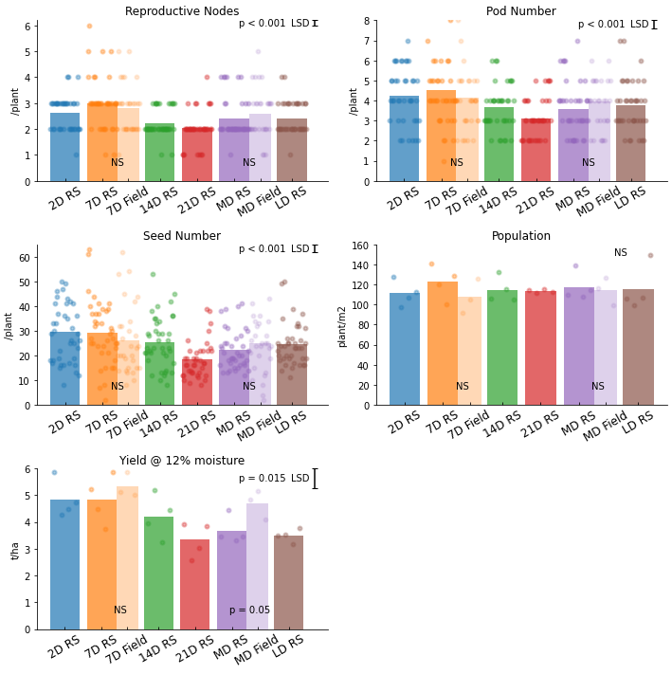

Figure 1. Reproductive node numbers, pod numbers, seed numbers, population and yield, for `Canterbury 37` peas grown in the Plant & Food Research rain shelter near Lincoln in 2021/22 with six different irrigation treatments, and for two sprinkler irrigation treatments in the adjacent field. Individual data points are shown by round symbols and bars represent the mean for each treatment. Different colours represent different irrigation treatments. The paired bars represent the same irrigation treatment, with the darker bar being data for peas drip irrigated under the rain shelter, and the lighter bar being those sprinkler irrigated in the field. The probabilities on top of these paired bars are from a t-test comparison of the two. Probabilities and 5% LSD values in the top corner of each graph are from an ANOVA for the rain shelter treatments. Treatments are described in the text.

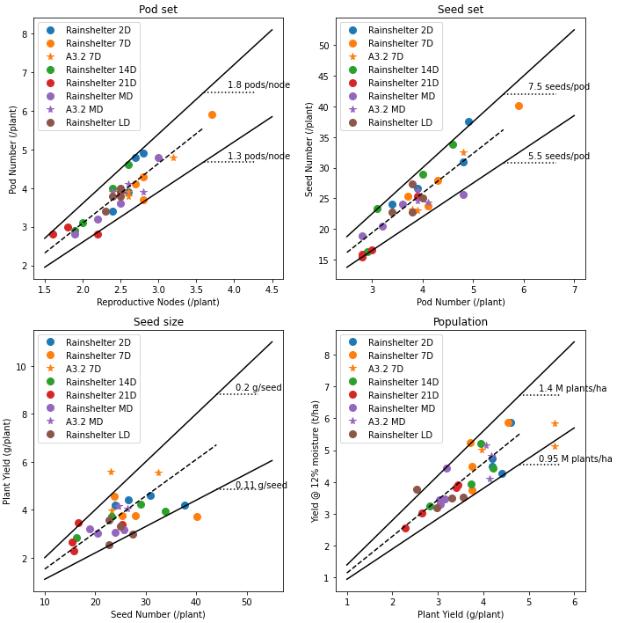

Figure . Yield component correlation graphs for `Canterbury 37` peas grown in the Plant & Food Research rain shelter near Lincoln in 2021/22 with six different irrigation treatments, and for two sprinkler irrigation treatments in the adjacent field (A3.2). Dashed lines represent the mean slope of the y and x variables (y/x) and solid lines represent the upper and lower bounds. Treatments are described in the text.

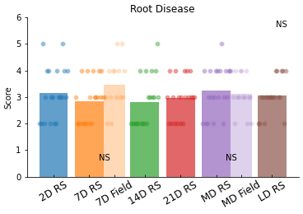

Figure . Root disease scores for `Canterbury 37` peas grown in the Plant & Food Research rain shelter near Lincoln in 2021/22 with six different irrigation treatments, and for two sprinkler irrigation treatments in the adjacent field. Individual data points are shown by round symbols and bars represent the mean for each treatment. Different colours represent different irrigation treatments. The paired bars represent the same irrigation treatment, with the darker bar being data for peas drip irrigated under the rain shelter, and the lighter bar being those sprinkler irrigated in the field. The probabilities on top of these paired bars are from a t-test comparison of the two. Probabilities and 5% LSD values in the top corner of each graph are from an ANOVA for the rain shelter treatments. The visually assessed scores were on a scale of 1–6, where 1 = not diseased and   
6 = heavily diseased Treatments are described in the text.

## Rain shelter canopy covers

There were few visible differences early in the crops’ duration, and all treatments achieved full canopy closure about mid December 2021. Treatment differences became apparent in January, with the 21D treatment plants losing green cover in its canopy most quickly. Plants in the MD, LD and 14D treatments all had a similar rate of canopy senescence (Figure 4). These are all treatments where the plants encountered some degree of water stress during or prior to this time. The 7D and the 2D irrigation treatments resulted in the longest survival of green canopy. All treatments reached full canopy senescence (measured as fraction of photosynthetically active radiation; fPAR = 0) between 18 and 25 January.

These results clearly show frequent irrigation throughout the season supported an extended crop duration. The plants in the MD and LD treatments senesced at the same rate in spite of the MD treatment involving weekly irrigation during the senescence period. This shows that moisture stress prior to the onset of canopy senescence can accelerate canopy decline later in the crop.

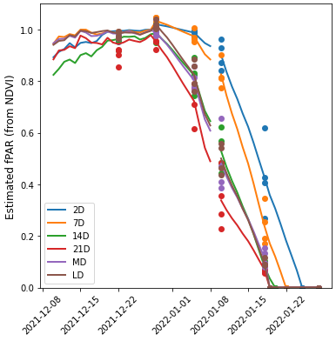

Figure . Estimated fPAR (fraction of photosynthetically active radiation) for `Canterbury 37` peas under six different irrigation treatments in the Plant & Food Research rain shelter near Lincoln. Values prior to 28 December 2021 were measured with continuously logged below canopy radiation sensors and beyond this date they were based on 5- to 7-day Normalized Difference Vegetation Index (NDVI) measurements (symbols) that were extrapolated out to daily values (lines). Treatments are described in the text.

## Rain shelter soil water deficits

Soil water deficit (SWD) was calculated for each treatment assuming the soil was at field capacity on the day soil moisture measurement commenced (Figure 5). Irrigation began on 3 December for relevant treatments and proceeded until plants in each treatment’s canopy were close to fully senesced (Figure 5). The 2D treatment maintained a SWD between 0 and 20 mm throughout the duration of the experiment. This is an important result because it shows that the amount of irrigation applied closely matched water use. Irrigation applications were calculated using a new approach based on IR canopy temperature, and the ability of this approach to maintain soil water content in a tightly defined range is encouraging.

The 7D, 14D and 21D treatments occupied a progressively wider range of soil water deficits, which was expected, as they had longer to dry down between progressively larger irrigation amounts. There was little difference between the MD and the LD treatments in December because weather conditions were cool and dull and the crops did not use much water. The LD treatment reached the greatest SWD by the end of the experiment (-85 mm) with the MD, 21D and 14D treatments all reaching a SWD around -60 mm by the end.

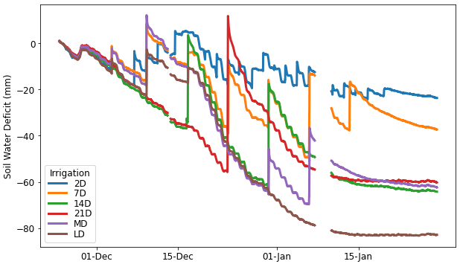

Figure . Soil water deficit for `Canterbury 37` peas grown in the Plant & Food Research rain shelter near Lincoln in 2021/22 with six different irrigation treatments. Treatments are described in the text.

## Rain shelter water extraction pattern

Changes in volumetric water content (VWC) at each depth are shown in Figure 6. The VWC fluctuated most in the top 15-cm layer where irrigation was added and crop water extraction was most significant. There appeared to be a difference between the VWC measured within the drill rows and that measured between drill rows for the 2D treatment, with VWC being lower within the drill rows. Fluctuations due to irrigation and root uptake were evident in the 15–30 and 30–60 cm layers, showing that peas are actively extracting water at these depths. Wetting from irrigation events did not make it to the 60–90 cm layer and gradual water extraction was evident from this layer during the period from the middle of December to mid-January. Water extraction from this layer was least for the 2D treatment (which had the smallest SWD) and greatest for the LD treatment (which had the largest SWD). Although there were gradual reductions in water content below 90 cm, these are attributed to gradual drainage as the reductions remained linear and crop water uptake would have shown a greater reduction around 1 January when crop transpiration was greatest.

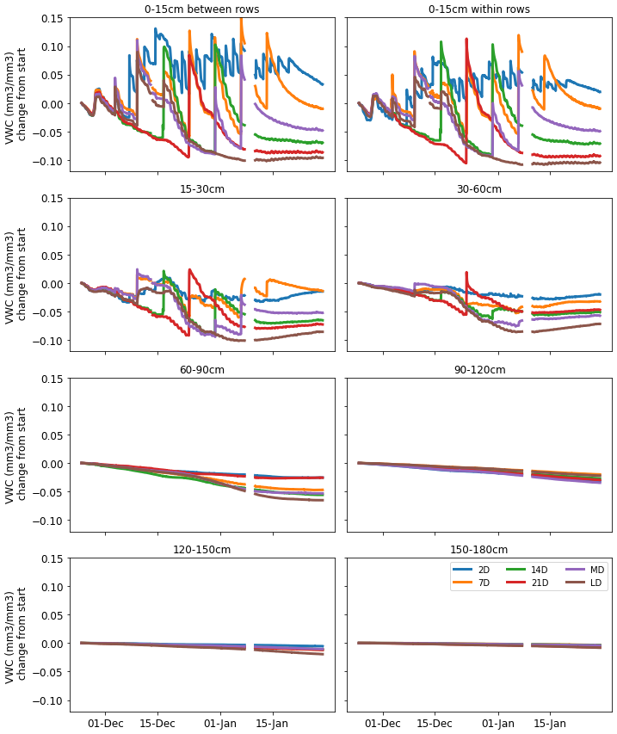

Figure . Change in water content (mm3/mm3) relative to starting value for soil layers down to 180 cm for `Canterbury 37` peas grown in the Plant & Food Research rain shelter near Lincoln in 2021/22 with six different irrigation treatments. Treatments are described in the text.

# Estimating crop water use using IR temperature

Daily crop water use was calculated from soil moisture data by summing the change of hourly reductions in water content and subtracting daily drainage. Daily drainage was estimated from night time changes in soil water content (when transpiration and evaporation would be minimal). Drainage was calculated as the change in profile water content between 2300 h and 0400 h each day and then multiplied to give a daily value (Figure 7). Drainage was about 1 mm per day in most cases but there were some spikes following irrigation events, particularly following the 50 mm irrigation applied to the 21D treatment on 23 December 2021.

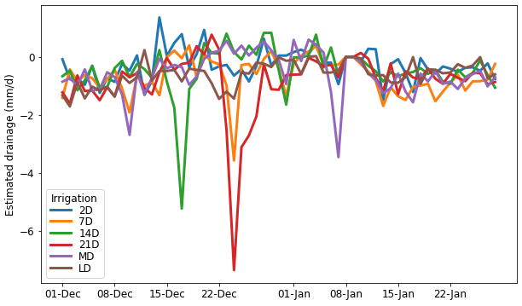

Figure . Drainage estimated from night time profile water fluxes for `Canterbury 37` peas grown in the Plant & Food Research rain shelter near Lincoln in 2021/22 with six different irrigation treatments. Treatments are described in the text.

Crop water use calculated from soil water measurements (markers) and estimated using the IRR and canopy temperature (lines) were accumulated over the duration of the pea crop for each irrigation treatment (Figure 8). There was very good agreement between the two methods of measuring water use for the 2D, 7D, and 21D treatments. The infra-red radiometers (IRR) method over-estimated for the LD treatment and underestimated water use slightly for the 14D and MD treatments.

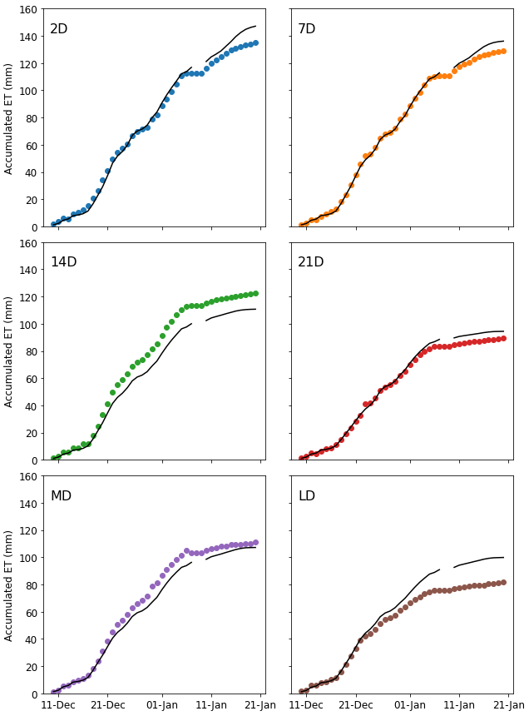

Figure . Accumulated evapotranspiration (ET) measured using soil moisture sensors (markers) and estimated using infra-red radiometers (IRR) temperature data (lines) for `Canterbury 37` peas grown in the Plant & Food Research rain shelter near Lincoln in 2021/22 with six different irrigation treatments. Treatments are described in the text.

# Concluding remarks

These experiments were a successful collaboration between Plant & Food Research and Carrfields Limited to provide information for fine-tuning the irrigation management of peas giving the following take away messages:

* Soil water deficit in excess of 40mm caused yield reductions regardless of the timing of stress.
* Peas were able to extract water to at least 60 cm depth.
* There was no evidence that wetting the canopy during flowering reduced seed set.
* The IRR method for measuring crop water use and scheduling irrigation shows substantial promise for pea crops.

# References

Brown HE, Jamieson PD, Hedley C, Maley S, George MJ, Michel AJ, Gillespie RN. 2021. Using infrared thermometry to improve irrigation scheduling on variable soils. Agricultural and Forest Meteorology 307: 108033.

Brown HE, Jamieson PD, Michel AJ, George MJ, Gillespie RN, Maley S. 2021. Developing a method for integrating canopy measurements into evapotranspiration predictions. Agricultural and Forest Meteorology 307: 108539.

Martin RJ, Jamieson PD, Wilson DR, Francis GS. 1990. The use of a rainshelter to determine the response of russet burbank potatoes to soil water deficit. Proceedings Annual Conference Agronomy Society of New Zealand 20: 99–101.